Nomination form for the Miss E form Napier Cup for
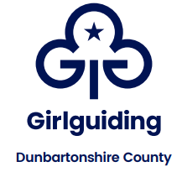
an Individual Achievement

I would like to nominate:

Name:
Unit:
Division:

The Miss E M Napier Cup is awarded for an individual’s exceptional achievement. This can be for fundraising, act of kindness, act of bravery, achievement in the face of adversity, doing something exceptional for Girlguiding or the community etc.

Please insert below (don’t worry if it goes over the page) why you feel your nominee should be considered for this award.

Your details:
Name:
Address:
Postcode:
Tel No.:
Email:
Membership No.:
Position in Guiding:
Date of Submission:

Please return your completed form to Helen Anderson by 14th December 2025 Countypresident@girlguidingdunbartonshire.org.uk

